Objective
Design and develop a windows-based program to send out WhatsApp message. The program is written using C# and Python.
This program will be called by HP-UX Core system and Whatsapp data is generated by HP-UX Core System and
copy into local PC client.

Folder Directory
Send Directory: c:/pa/wa2u/live *Host System will download wa2u.txt + attachments
Backup Directory: c:/pa/wa2u/backup *After send, move from live files over to here
Log Directory: c:/pa/wa2u/log *Keep all the error logs

Data Structure
Program ID: c:/pa/wal2u/wa2u.exe
Data ID: c:/pa/wa2u/live/wa2u.txt
Record size: 100 characters with carried return line-feed
Note: Data is generated by HP-UX Core System

Code X(04) | Explanation | Data X(95) | EOR X(01)
M00 | Message App | Reserve for other message app | #
M10 | Sender | Reserve for Sender Phone # (0112323323) | #
M20 | Sender Password | Reserve for Sender Password | #
M30 | Receiver | Receiver Phone # (0123453555) | #
M30 | Receiver | Receiver Phone # (0112323323) | #
M30 | Receiver | Receiver Phone # (0123453555) | #
M30 | Receiver | Receiver Phone # (0198374929) | #
M40 | Message | COKA COLA MALAYSIA | #
M40 | Message | Dear Mr Albert Chin | #
M40 | Message |  | #
M40 | Message | Please to be informed we have ship out: | #
M40 | Message | 1. PO#123 | Model ABC | Qty 1,000 | #
M40 | Message | 2. PO#123 | Model XYZ | Qty 2,000 | #
M40 | Message | 3. PO#994 | Model XAA | Qty 3,000 | #
M40 | Message | Lorry Number: ABC 4857 | #
M40 | Message | Departure: 20/08/2019 Tue, 14:00 | #
M40 | Message | Arrival: 20/08/2019 Tue, 16:45 EST | #
M40 | Message |  | #
M40 | Message | Thank you | #
M40 | Message | Muda Packaging Industries (Logistic Department) | #
M50 | Attachment | C:\pa\wa2u\123.pdf | #

System Architecture
Any PC that connects to HP-UX Core System is able to run WA2U installed in PC.

WhatsApp via Wa2u


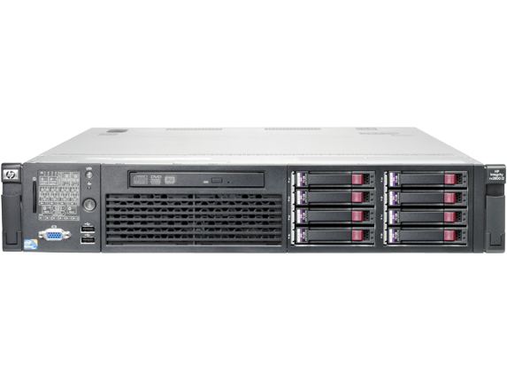
HP-UX Core System

PC Client
(Win 7 or 8)

Sample wa2u.txt
Kah Gian you can edit this file then ask Susan and Min to run her own wa2u.exe
In short this text data is generate by CPS Backend program in COBOL

1234567890123456789012345678901234567890123456789012345678901234567890123456789012345678901234567890
M00 #
M10 #
M20 #
M30 0193834839 #
M30 0187364234 #
M30 0183848294 #
M40 COKA COLA MALAYSIA #
M40 #
M40 Please to be informed we have ship out: #
M40 1. PO#123 | Model ABC | Qty 1,000 #
M40 2. PO#123 | Model XYZ | Qty 2,000 #
M40 3. PO#994 | Model XAA | Qty 3,000 #
M40 Lorry Number: ABC 4857 #
M40 Departure: 20/08/2019 Tue, 14:00 #
M40 Arrival: 20/08/2019 Tue, 16:45 EST #
M40 #
M40 Thank you #
M40 Muda Packaging Industries (Logistic Department) #
M50 C:\pa\wa2u\123.pdf #

Kah Gian there are only 2 rules Susan and Min need to follow:
Rule 1 develop wa2u.exe that read wa2u.txt and send out whatapps message
Rule 2 go back to rule 1

